PROJECT REPORT ON

**ESTHETIQUE BEAUTY & MAKEUP STUDIO**

*In partial fulfilment of the requirements for the award of the diploma in*

**SOFTWARE DEVELPOMENT AND SYSTEM ADMINISTRATION**

**Level-5 Diploma Certificate National Skill Development Corporation New Delhi**

***Submitted by* KRISHNA K.B ROLL NO: 212520**



**DEPARTMENT OF SOFTWARE DEVELOPMENT AND SYSTEM ADMINISTRATION**

**(2021)**

**M.E.S COLLEGE MARAMPALLY ALUVA-7 AFFILIATED TO MAHATMA GANDHI UNIVERSITY**

**KERALA**

**M.E.S COLLEGE, MARAMPALLY ALUVA-7**



**DEPARTMENT OF SOFTWARE DEVELOPMENT AND SYSTEM ADMINISTRATION**

***Certificate***

This to certify that the report entitled

**ESTHETIQUE BEAUTY & MAKEUP STUDIO**

Has been submitted by KRISHNA K.B ROLL NO:212520

*In partial fulfilment of the award of the diploma in*

**SOFTWARE DEVELOPMENT AND SYSTEM ADMINISTRATION**

**Level-5 Diploma Certificate National Skill Development Corporation New Delhi**

During the academic year 2021 Register No: ………………….

Staff in charge B.Voc Coordinator Nodal Officer Head of the department

submitted for the examination held on …………………………

Examiners

1. 2.

**ACKNOWLEDGEMENT**

First of all, I bow my head before the God Almighty in prayer and gratitude for all the blessings showered on me to complete the project work successfully.

I express my heartfelt gratitude to Ms. JASMIN, Principal and Mrs. ASHIKA K A, Head of the Department, Software Development and System Administration, MES College Marampally for their cooperation and guidance throughout the course of the project work.

I am deeply indebted to my project guide Ms. BISMI, Assistant Professor, SDSA for her continuous encouragement and valuable guidance given to me. I am also very thankful to all the faculties of the department of Software Development and System Administration for their timely suggestions and encouragement.

I extend my sincere thanks to all the friends for their provoking suggestions and enlightening discussions which helped me to complete my project successfully.

And last but not the least, I extend my heartfelt thanks to my beloved parents, without their support I could never have reached this point.

KRISHNA K.B

|  |  |
| --- | --- |
| **Contents** |  |
|  | **Page No.** |
| 1. Introduction | 1 |
| 1.1. Overview of the system | 2 |
| 1.2. Problem definition and objective | 2 |
| 2. System Analysis | 3 |
| 2.1. Introduction | 4 |
| 2.2. Existing system | 5 |
| 2.3. Proposed system | 5 |
| 2.3.1. Web pages and features | 5 |
| 2.3.2. Benefits of the proposed system | 6 |
| 2.4. Feasibility study | 7 |
| 2.5. System specification | 8 |
| 2.5.1. Software specification | 8 |
| 2.5.2. Tools/platform | 8 |
| 2.5.3. Hardware specification | 10 |
| 3. System Design | 11 |
| 3.1. Introduction | 12 |
| 3.2. Design of Web pages | 13 |
| 4. System Development | 18 |
| 4.1. Pseudo code | 19 |
| 5. Conclusion | 64 |
| 6. Appendix | 65 |
| 6.1. Web page – Screenshots | 66 |
| 7. Bibliography | 71 |

**1. INTRODUCTION**

## OVERVIEW OF THE SYSTEM

“Esthetique” is a complete beauty and makeup studio (salon). And through the online website we are reaching out to our customers to provide all the details of new packages, offers, new releases etc.

Customers can easily book appointment earlier and we provide all the details of prices in our online site.

Customers can login in order to receive latest updates, latest treatments & services.

* 1. **PROBLEM DEFINITION AND OBJECTIVE**

Customers can **get instant access** of our salon business information

To get feedback from real customer on salon website which creates interest in visitors to become our customer and maximize our business revenue.

Improve business with the help of **customer feedback**

Plays an important role in **creating social network**

To **promote our salon services or products.**

1. **SYSTEM ANALYSIS**

## INTRODUCTION

System analysis is a general term that refers to a structured process for identifying and solving problems. Analysis implies the process of breaking something down into its parts so that the whole may be understood. The definition of systems analysis includes not only the process of analysis, but also that of synthesis, which is the process of putting parts together to form a new whole. System analysis works with users to identify goals and build systems to achieve them. System analysis is an important phase of any system development process. The system is studied to the minutest details and analyzed. The system analyst plays the role of an interrogator and dwells deep into the working of the present system. In analysis, a detailed study of the operations performed by a system and their relationships within and outside of the system is done. A key question considered here is, “what must be done to solve the problem?” One aspect of analysis is defining the boundaries of the system and view as a whole and the inputs to the system are identified. The outputs from the system are traced through the various processes that the inputs to the system are identified. During analysis, data are collected on available files, decision points and transaction handled by present system

During study phase, I have done a preliminary analysis sufficient depth to permit a technical and economic evaluation of proposed system. The study of existing system helps to determine what the problems are. The following are the disadvantages of the existing system:

* + - Not User Friendly
    - Can’t handle to many users
    - Time consuming

.

## EXISTING SYSTEM

There are no proper beauty salons who have an own website portal to give more details to the customers. Customers can only contact them through social medias or directly.

Existing system does not provide proper information about the services and price details to customers. Existing systems are not at all working properly as per the need of customers.

## PROPOSED SYSTEM

* Customers can **get instant access** of our salon business information
* To get feedback from real customer on salon website which creates interest in visitors to become our customer and maximize our business revenue.
* improve business with the help of **customer feedback**
* plays an important role in **creating social network**
* To **promote our salon services or products.**

## WEBPAGES AND FEATURES

The visitor is assumed to have basic knowledge on how to use a computer and the Internet. Visitor will get the provision to explore the webpage, watch quality photograph and know about.

The web site is static and it contains five web pages: 1.HOME

1. SERVICES
2. LOGIN
3. ABOUT US
4. CONTACT US

**HOME:** The main home page-first page of the website. Just an overview about bonus plans and salon highlights.

**SERVICES**: Displays the list of services available and its prices.

**LOGIN:** a login page for customers.

**ABOUT US:** (about our Team, Customers reviews, Gallery)

**CONTACT US:** page for get in touch with our customers.where customers can provide their details and contact us.

## BENEFITS OF THE PROPOSED SYSTEM

The benefits of the proposed system are:

* + - * Flexible hours
      * Low costs
      * User – friendly
      * Easy to understand
      * Provide the opportunity to make appointments in advance
      * Effective communication is established
      * Web platform will help to access from anywhere
      * Gives clear idea about the location of salon
      * Help to gather information about the services provided by the salon.

## FEASIBILITY STUDY

The preliminary investigations examine project feasibility. The main objective of this study is to examine whether the proposed system is feasible or not. Mainly there are three types of feasibility study to which the proposed system is subjected.

Operational feasibility determines if the human resources are available to operate the system once it has been installed. The resources that are required to implement or install are already available with the organization. The people of the organization need no exposure to computer but have to be trained to use this particular software. A few of them will be trained. Further, training is very less.

Technical feasibility assesses whether the current technical resources are sufficient for the new system. If they are not available, can they be upgraded to provide the level of technology necessary for the new system? It checks whether the proposed system can be implemented in the present system without supporting the existing hardware.

Economic feasibility determines whether the time and money are available to develop the system. It also includes the purchase of new equipment, hardware, and software. Software product must be cost effective in the development, on maintenance and in the use. Since the hardware and resources are already available with the organization and the organization can afford to allocate the required resources.

# SYSTEM SPECIFICATION

### SOFTWARE SPECIFICATION

OPERATING SYSTEM : WINDOWS XP OR HIGHER VERSION FRONT END : NOTEPAD, VISUAL STUDIO CODE

* + 1. **TOOLS / PLATFORM**

### HTML

Hypertext Markup Language (HTML) is the standard markup language for documents designed to be displayed in a web browser. It can be assisted by technologies such as Cascading Style Sheets (CSS) and scripting languages such as JavaScript.

Web browsers receive HTML documents from a web server or from local storage and render the documents into multimedia web pages. HTML describes the structure of a web page semantically and originally included cues for the appearance of the document.

HTML elements are the building blocks of HTML pages. With HTML constructs, images and other objects such as interactive forms may be embedded into the rendered page. HTML provides a means to create structured documents by denoting structural semantics for text such as headings, paragraphs, lists, links, quotes and other items. HTML elements are delineated by tags, written using angle brackets. Tags such as <img> and <input> directly introduce content into the page. Other tags such as <p> surround and provide information about document text and may include other tags as sub-elements. Browsers do not display the HTML tags, but use them to interpret the content of the page.

HTML can embed programs written in a scripting language such as JavaScript, which affects the behavior and content of web pages. Inclusion of

CSS defines the look and layout of content. The World Wide Web Consortium (W3C), former maintainer of the HTML and current maintainer of the CSS standards, has encouraged the use of CSS over explicit presentational HTML since 1997.

**MICROSOFT NOTEPAD**

Notepad is a simple text editor for Microsoft Windows and a basic textediting program which enables computer users to create documents. It was first released as a mouse-based MS-DOS program in 1983, and has been included in all versions of Microsoft Windows since Windows 1.0 in 1985.A web browser (commonly referred to as a browser) is a software application for accessing information on the World Wide Web. Each individual web page, image, and video is identified by a distinct Uniform Resource Locator (URL), enabling browsers to retrieve these resources from a web server and display them on a user's device.

### WEB BROWSER

A web browser is not the same thing as a search engine, though the two are often confused. For a user, a search engine is just a website, such as google.com, that stores searchable data about other websites. But to connect to a website's server and display its web pages, a user must have a web browser installed on their device.

As of March 2019, more than 4.3 billion people use a browser, which is about 55% of the world’s population. The most popular browsers are Chrome, Firefox, Safari, Internet Explorer, and Edge.

### VISUAL STUDIO CODE

Visual Studio Code is a lightweight but powerful source code editor which runs your desktop and is available for Windows, macOS and Linux. It comes with

built-in support for JavaScript, TypeScript and Node.js and has a rich ecosystem of extensions for other languages (such as C++, C#, Java, Python, PHP, Go) and runtimes (such as .NET and Unity).

## HARDWARE SPECIFICATION

CPU TYPE: INTEL i5

CLOCK SPEED: 3.0 GHZ OR ABOVE RAM SIZE: 512 MBDDR 8 RAM. HARD DISK CAPACITY: 256 GB MONITOR TYPE: LED MONITOR

KEYBOARD TYPE: MULTIMEDIA KEYBOARD

# SYSTEM DESIGN

* 1. **INTRODUCTION**

The web design process starts with a visual concept, which you could sketch by hand or with software like Photoshop. Then, you use HTML and CSS to build the website. HTML and CSS are the codes for writing web pages. HTML handles the basic structure and ‘bones’ of yourpage, while CSS handles the style and appearance.

Web design is the visual aesthetics and page layout of a website. It goes hand-in-hand with web development in the creation of a static website or dynamic web application.

Even if you don’t consider yourself a creative person, it’s still a goodidea to learn web design. No matter whether you want to make static websites or dynamic web applications, design is an important part of theprocess. The design is the first thing people notice when they arrive on a website, and if it’s not good enough, they’ll leave. You don’t want to createa site that frustrates people.

If you do identify yourself as a creative person, you might even consider a career as a web designer. Today, there is a huge need for competent web designers with up-to-date skills. It’s not an opportunity to be sneezed at.

# DESIGN OF WEBPAGES

## HOME PAGE



INFORMATIONS

BANNER

* + 1. **SERVICE PAGE**

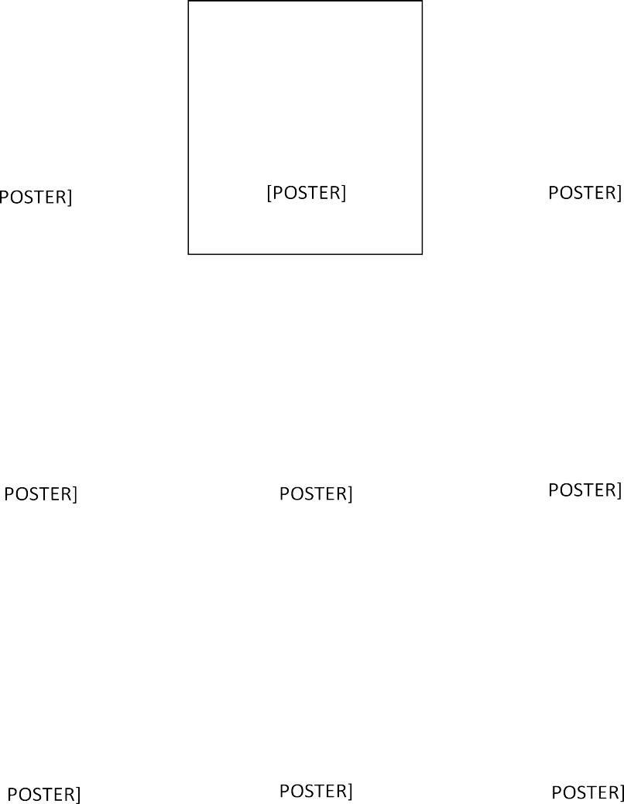

[

[

[

[

[

[

[

[

* + 1. **LOGIN PAGE**

FOOTER

LOGIN FORM

IMAGE

HEADER & NAVIGATION BAR

## ABOUT US PAGE

HEADER & NAVIGATION BAR

ABOUT THE TEAM

CUSTOMER REVIEWS

FOOTER

* + 1. **CONTACT US PAGE**



# SYSTEM DEVELOPMENT

## PSEUDO CODE

* + 1. **HOME PAGE - HTML FILE**

<!DOCTYPE html>

<html lang="en">

<head>

<meta charset="UTF-8">

<meta http-equiv="X-UA-Compatible" content="IE=edge">

<meta name="viewport" content="width=device-width, initial-scale=1.0">

<title> Esthetique beauty & makeup studio</title>

<! font awesome cdn-->

<link rel="stylesheet" href="https://cdnjs.cloudflare.com/ajax/libs/font- awesome/6.0.0/css/all.min.css">

<!-----custom css-->

<link rel="stylesheet" href="css/styles.css">

<!--custom js link-->

<script src="js/script.js" defer></script>

<!----other links-->

<link rel="stylesheet" href="https://maxcdn.bootstrapcdn.com/bootstrap/4.1.3/css/bootstrap.min.css ">

<script src="https://ajax.googleapis.com/ajax/libs/jquery/3.3.1/jquery.min.js"></scrip t>

<script src="https://cdnjs.cloudflare.com/ajax/libs/popper.js/1.14.3/umd/popper.min. js"></script>

<script src="https://maxcdn.bootstrapcdn.com/bootstrap/4.1.3/js/bootstrap.min.js"><

/script>

<link href="https://fonts.googleapis.com/css?family=Playfair+Display:400,700,900" rel="stylesheet">

<link rel="stylesheet" href="https://cdnjs.cloudflare.com/ajax/libs/font- awesome/4.7.0/css/font-awesome.min.css">

<link href="https://fonts.googleapis.com/css?family=Roboto:100,300,400,500,700" rel="stylesheet">

</head>

<body>

<!--header section starts-->

<header class="header">

<a href="index.html" class="logo" style="text-decoration: none;"> ESTHETIQUE</a>

<nav class="navbar">

<ul>

<li><a href="index.html">HOME</a></li>

<li><a href="service.html">SERVICES </a></li>

<li><a href="login.html">LOGIN</a></li>

<li><a href="about.html">ABOUT</a></li>

<li><a href="contact.html">CONTACT US</a></li>

</ul>

</nav>

<div class="icons">

<div id="menu-btn" class="fas fa-bars"></div>

<div id="search-btn" class="fas fa-search" style="display: none;" ></div>

<a href="login.html" class="fas fa-user"></a>

<a href="cart.html" class="fas fa-shopping-cart"></a>

</div>

<form action="" class="search-form">

<input type="search" name="" placeholder="search" id="search-box">

<label for="search-box" class="fas fa-search"></label>

</form>

</header>

<!--header section end-->

<!---home section starts-->

<section class="home">

<div class="bg-img">

<div class="content">

<p>CLUB ESTHETIQUE MEMBERSHIP PROGRAM</p>

<h1>30% OFF FOR GOLD MEMBERS</h1>

<span>GOLD,SILVER & BRONZE PLANS</span><br>

<a href="#" class="btn1" >BUY MEMBERSHIP</a>

<a href="bonusdeals.html" class="btn2">BONUS DEALS</a>

</div>

</div>

</section>

<!---home section end-->

<!---banner section starts-->

<section class="banner-container">

<div class="banner-title">

<h2 class="bonus-title">BONUS DEALS FOR MEMBERS</h2>

<div class="underline"></div>

<div class="clearfix-section">

<h2 style="text-align: center; font-family: 'raleway';">BE A CLUB ESTHETIQUE MEMBER TO ENJOY THE FOLLOWING DEALS</h2>

<h2 style="text-align: center; font-family: 'raleway';">

<span style="color: #ff2a00;">

<strong>

<span style="text-decoration: underline; padding: 20px;">AN ACTIVE MEMBERSHIP IS REQUIRED TO REDEEM THE OFFERS</span>

</strong></span></h2>

<h2 style="text-align: center;">

<strong>

<span style="color: #ff2a00; text-decoration: underline;padding: 20px;">ONLINE PURCHASE MANDATORY</span>

</strong></h2>

</div></div></section>

</div>

</div>

</div>

</div>

</section>

<! container-->

<!---offer section ends-->

<div class="main">

<div class="cards">

<div class="card-image">

<img src="images/HairBotox_800x.png">

<div class="middle">

<div class="middle-text">QUICK VIEW</div>

</div>

<span class="label danger">SALE</span>

</div>

<div class="card-title">

<h3> KERATIN TREATMENT-MEMBERS ONLY DEAL</h3>

</div>

<div class="des">

<p><del style="text-decoration: line-through;"><ins style="color: #ff2a00;">Rs.18,000.00</ins></del>from Rs.4,999.00</p>

</div>

</div>

<!----cardsss-->

<div class="cards">

<div class="card-image">

<img src="images/HairSmoothening_800x.png">

<div class="middle">

<div class="middle-text">QUICK VIEW</div>

</div>

<span class="label danger">SALE</span>

</div>

<div class="card-title">

<h3> HAIR SMOOTHENING - MEMBERS ONLY DEAL</h3>

</div>

<div class="des">

<p><del style="text-decoration: line-through;"><ins style="color: #ff2a00;">Rs.13,000.00</ins></del>from Rs.4,999.00</p>

</div>

</div>

</div>

<!--- offers ends-->

<! most trusted salon-->

<div class="banner-title">

<h2 class="bonus-title" style="font-family: 'opensans';">THE MOST TRUSTED SALON BRAND IN KOCHI</h2>

<div class="underline"></div>

<h4 style="font-family: 'Raleway',sans-serif;"></h4>

Spend a little time to enjoy our services. You'll not be disappointed. That's our promise.

An excellent location combined with tasteful interiors, affordable services and qualified staff will result in a time well spent feeling.

<div class="icons-container" style="margin-top: 10px;">

<div class="better-icons">

<img src="images/free-icon-lotion-1590.png" alt="">

<h3 class="better-iconstext"> BETTER PRODUCTS</h3>

</div>

<div class="better-icons">

<img src="images/free-mirror-icon-1608.png" alt="">

<h3 class="better-iconstext"> BETTER AMBIENCE</h3>

</div>

<div class="better-icons">

<img src="images/free-icon-dye-1603.png" alt="">

<h3 class="better-iconstext"> BETTER HYGIENE</h3>

</div>

</div>

<! club esthetique membership-->

<section class="membership">

<h2 style="font-family: 'opensans'; color: white;">ABOUT CLUB MEMBERSHIP</h2>

<div class="underline"></div>

<div class="option-text">

<h2 style="font-family: 'opensans';text-decoration: underline; ">ABOUT CLUB MEMBERSHIP</h2>

</div>

<div class="description">

<p style="font-size: 16px; font-weight: 300;">

Join Club ESTHETIQUE, our exclusive annual membership program, to get amazing discounts each time you visit any of ESTHETIQUE Salon branches. Moreover, our flagship MG Road branch is exclusively reserved for Club ESTHETIQUE members.

<br> </p>

<p style="font-size: 16px;font-weight: 300;">There are multiple plans to choose from. The discounts and annual fees vary according to the plan.</p><br>

<p style="font-family: 'Raleway',sans-serif;font-size: 16px;"><strong>Why should you become a member?</strong></p>

<p style="font-size: 16px; font-weight: 300;">

* + - 1. Up to 30% discount based on the membership plan <br>
      2. Your guests can get 10% discount <br>
      3. Family members get 50% discount on membership fee <br>
      4. Access to members only branch at MG Road <br>
      5. Exclusive deals for members </p>

<p style="font-family: 'Raleway',sans-serif; font-size: 16px;">

<strong>Terms & Conditions</strong>

</p>

<p style="font-size: 16px; font-weight: 300;">

1. Membership validity is for 1 year from the date of purchase <br>
2. Membership discounts are not valid for combo offers/bridal services/products <br>
3. Membership discounts not allowed to combine with any other discounts <br>
4. Once activated no cancellation/refund is allowed <br>
5. Membership is valid at all branches of ESTHETIQUE Salon <br>
6. Membership can't be shared <br>
7. Access to MG Road branch is limited to Members and their guests<br></p>

</p>

</div>

<div class="underline"></div>

</section>

<!--footer secion start-->

<footer class="footer">

<div class="container">

<div class="row">

<div class="footer-col">

<h4> ESTHETIQUE</h4>

<ul>

<li><a href="#">home</a></li>

<li><a href="#">services</a></li>

<li><a href="#">about us</a></li>

<li><a href="#">blogs</a></li>

</ul>

</div>

<div class="footer-col">

<h4>get help</h4>

<ul>

<li><a href="#">my account</a></li>

<li><a href="#">FAQ</a></li>

<li><a href="#">my cart</a></li>

<li><a href="#">terms & use</a></li>

</ul>

</div>

<div class="footer-col">

<h4>follow us</h4>

<div class="social-links">

<a href="#"><i class="fab fa-facebook-f"></i></a>

<a href="#"><i class="fab fa-twitter"></i></a>

<a href="#"><i class="fab fa-instagram"></i></a>

<a href="#"><i class="fab fa-linkedin"></i></a>

</div>

</div>

</div>

</div>

</footer>

<!--footer secion end-->

</body>

</html>

## SERVICES PAGE – HTML FILE

<!DOCTYPE html>

<html lang="en">

<head>

<meta charset="UTF-8">

<meta http-equiv="X-UA-Compatible" content="IE=edge">

<meta name="viewport" content="width=device-width, initial-scale=1.0">

<title>SERVICES-ESTHETIQUE BEAUTY SALON</title>

<link rel="stylesheet" href="css/services.css">

<! font awesome cdn-->

<link rel="stylesheet" href="https://cdnjs.cloudflare.com/ajax/libs/font- awesome/6.0.0/css/all.min.css">

</head>

<body>

<!--header-->

<header class="header-section">

<a href="index.html" class="logo" style="font-family: 'cinzel'; text-decoration: none;color: rgb(255, 255, 255);">ESTHETIQUE</a>

<nav class="navbar">

<ul>

<li><a href="index.html">HOME</a></li>

<li><a href="service.html">SERVICES </a></li>

<li><a href="login.html">LOGIN</a></li>

<li><a href="about.html">ABOUT</a></li>

<li><a href="contact.html">CONTACT US</a></li>

</ul>

</nav>

<div class="icons">

<a href="login.html"><i class="fas fa-user"></i></a>

<a href="cart.html"><i class="fas fa-shopping-cart"></i></a>

</div>

</header>

<!---header ends-->

<div class="wrapper">

<h1>OUR SERVICES</h1>

<div class="underline"></div><br>

<p>

Spend a little time to enjoy our services. You'll not be disappointed. That's our promise.<br>

An excellent location combined with tasteful interiors, <br>affordable services and qualified staff will result in a time well spent feeling.

</p>

<div class="content-box">

<div class="card">

<img src="images/facials.png">

<a href="facials.html" style="text-decoration: none;color: black;"><h2>FACIALS</h2></a>

<p> KEEP YOUR SKIN CLEAN AND FRESH

</p>

</div>

<div class="card">

<img src="images/manicure.png">

<a href="manicure.html" style="text-decoration: none;color: black;"><h2>MANICURE & PEDICURE</h2></a>

<p> NEVER FEEL SHAME AGAIN

</p>

</div>

<div class="card">

<img src="images/waxing.png">

<a href="waxing.html" style="text-decoration: none;color: black;">

<h2>WAXING</h2></a>

<p> THE PINNACLE OF PERSONAL HYGIENE</p>

</div>

<div class="card">

<img src="images/haircut.png">

<a href="hairservice.html" style="text-decoration: none;color: black;">

<h2>HAIR SERVICES</h2></a>

<p> MAINTAIN YOUR CIVILISED LOOK

</p>

</div>

<div class="card">

<img src="images/hair treatment.png">

<a href="hairtreatment.html" style="text-decoration: none;color: black;">

<h2>HAIR TREATMENTS</h2></a>

<p> LOOK VIBRANT AND INTERESTING

</p>

</div>

<div class="card">

<img src="images/bodyspa.png">

<a href="bodyservice.html" style="text-decoration: none; color: black;"><h2>BODY SERVICES</h2></a>

<p> PAMPER YOUR BODY

</p>

</div>

<div class="card">

<img src="images/bridal.png">

<a href="bridal.html" style="text-decoration: none;color: black;"><h2>BRIDAL SERVICES</h2></a>

<p> GET READY FOR A NEW LIFE

</p>

</div>

</div>

</div>

<!--- footer-->

<footer class="footer">

<div class="container">

<div class="row">

<div class="footer-col">

<h4> ESTHETIQUE</h4>

<ul>

<li><a href="index.html">home</a></li>

<li><a href="service.html">services</a></li>

<li><a href="about.html">about us</a></li>

<li><a href="#">blogs</a></li>

</ul>

</div>

<div class="footer-col">

<h4>get help</h4>

<ul>

<li><a href="#">my account</a></li>

<li><a href="#">FAQ</a></li>

<li><a href="#">my cart</a></li>

<li><a href="#">terms & use</a></li>

</ul>

</div>

<div class="footer-col">

<h4>follow us</h4>

<div class="social-links">

<a href="#"><i class="fab fa-facebook-f"></i></a>

<a href="#"><i class="fab fa-twitter"></i></a>

<a href="#"><i class="fab fa-instagram"></i></a>

<a href="#"><i class="fab fa-linkedin"></i></a>

</div>

</div>

</div>

</div>

</footer>

</body>

</html>

## LOGIN PAGE – HTML FILE

<!doctype html>

<html lang="en">

<head>

<!-- Required meta tags -->

<meta charset="utf-8">

<meta name="viewport" content="width=device-width, initial-scale=1">

<!-- Bootstrap CSS -->

<link href="[https://cdn.jsdelivr.net/npm/bootstrap@5.1.3/dist/css/bootstrap.min.cs](https://cdn.jsdelivr.net/npm/bootstrap%405.1.3/dist/css/bootstrap.min.cs) s" rel="stylesheet" integrity="sha384- 1BmE4kWBq78iYhFldvKuhfTAU6auU8tT94WrHftjDbrCEXSU1oBoqyl2QvZ6jIW 3" crossorigin="anonymous">

<! font awesome cdn-->

<link rel="stylesheet" href="https://cdnjs.cloudflare.com/ajax/libs/font- awesome/6.0.0/css/all.min.css">

<title>Customer login-ESTHETIQUE</title>

<body>

<!--header-->

<header class="header-section">

<a href="index.html" class="logo" style="font-family: 'cinzel'; text-decoration: none;color: rgb(255, 255, 255);">ESTHETIQUE</a>

<nav class="navbar">

<ul>

<li><a href="index.html">HOME</a></li>

<li><a href="service.html">SERVICES </a></li>

<li><a href="login.html">LOGIN</a></li>

<li><a href="about.html">ABOUT</a></li>

<li><a href="contact.html">CONTACT US</a></li>

</ul>

</nav>

<div class="icons">

<a href="login.html"><i class="fas fa-user"></i></a>

<a href="cart.html"><i class="fas fa-shopping-cart"></i></a>

</div>

</header>

<!---header ends-->

<section class="form my-4 mx-5">

<div class="container">

<div class="row no-gutters">

<div class="col-lg-5">

<img src="images/log.jpg" class="img-fluid">

</div>

<div class="col-lg-7 px-5 pt-5">

<h2 class="font-weight-light py-3" style="font-family: 'Raleway'; font-weight: 100;">CUSTOMER LOGIN</h2>

<form id="form" method="post">

<div class="form-row">

<div class="col-lg-7">

<input type="email" id="email" class="form-control my-3 p-3" placeholder="Enter your Email">

</div>

</div>

<div class="form-row">

<div class="col-lg-7">

<input type="password" id="password" class="form-control my-3 p-3" placeholder="Enter your password">

</div>

</div>

<div class="form-row">

<div class="col-lg-7">

<input type="submit" value="login" class="btn1 mt-3 mb-5">

</div>

</div>

<a href="#" style="font-style:emphasised; color: #03a196;">Forgot password</a>

<p>New customer? <a href="#" style="color: #03a196;">Sign up</a></p>

</form>

</div>

</div>

</div>

</section>

<!--- footer-->

<footer class="footer">

<div class="container">

<div class="footer-row">

<div class="footer-col">

<h4> ESTHETIQUE</h4>

<ul>

<li><a href="index.html">home</a></li>

<li><a href="service.html">services</a></li>

<li><a href="about.html">about us</a></li>

<li><a href="#">blogs</a></li>

</ul>

</div>

<div class="footer-col">

<h4>get help</h4>

<ul>

<li><a href="#">my account</a></li>

<li><a href="#">FAQ</a></li>

<li><a href="#">my cart</a></li>

<li><a href="#">terms & use</a></li>

</ul>

</div>

<div class="footer-col">

<h4>follow us</h4>

<div class="social-links">

<a href="#"><i class="fab fa-facebook-f"></i></a>

<a href="#"><i class="fab fa-twitter"></i></a>

<a href="#"><i class="fab fa-instagram"></i></a>

<a href="#"><i class="fab fa-linkedin"></i></a>

</div>

</div>

</div>

</div>

</footer>

<!-- Optional JavaScript; choose one of the two! -->

<!-- Option 1: Bootstrap Bundle with Popper -->

<script src="[https://cdn.jsdelivr.net/npm/bootstrap@5.1.3/dist/js/bootstrap.bundle.m](https://cdn.jsdelivr.net/npm/bootstrap%405.1.3/dist/js/bootstrap.bundle.m) in.js" integrity="sha384- ka7Sk0Gln4gmtz2MlQnikT1wXgYsOg+OMhuP+IlRH9sENBO0LRn5q+8nbTov4+1 p" crossorigin="anonymous"></script>

<!-- Option 2: Separate Popper and Bootstrap JS -->

<!--

<script src="[https://cdn.jsdelivr.net/npm/@popperjs/core@2.10.2/dist/umd/popper.](https://cdn.jsdelivr.net/npm/%40popperjs/core%402.10.2/dist/umd/popper) min.js" integrity="sha384- 7+zCNj/IqJ95wo16oMtfsKbZ9ccEh31eOz1HGyDuCQ6wgnyJNSYdrPa03rtR1zdB" crossorigin="anonymous"></script>

<script src="[https://cdn.jsdelivr.net/npm/bootstrap@5.1.3/dist/js/bootstrap.min.js"](https://cdn.jsdelivr.net/npm/bootstrap%405.1.3/dist/js/bootstrap.min.js) integrity="sha384- QJHtvGhmr9XOIpI6YVutG+2QOK9T+ZnN4kzFN1RtK3zEFEIsxhlmWl5/YESvpZ1 3" crossorigin="anonymous"></script>

-->

</body>

<script>

var form = document.getElementById('form') var error=[] form.addEventListener('submit',function(e){ e.preventDefault()

var email=document.getElementById('email')

var password=document.getElementById('password')

if(email.value == ""){ alert("enter a valid email")

}

if(password.value == "" ) alert("enter your password")

})

</script>

</html>

## ABOUT US PAGE- HTML FILE

<!DOCTYPE html>

<html lang="en">

<head>

<meta charset="UTF-8">

<meta http-equiv="X-UA-Compatible" content="IE=edge">

<meta name="viewport" content="width=device-width, initial-scale=1.0">

<title>Document</title>

<! font awesome cdn-->

<link rel="stylesheet" href="https://cdnjs.cloudflare.com/ajax/libs/font- awesome/6.0.0/css/all.min.css">

</head>

<body>

<!--header-->

<header class="header-section">

<a href="index.html" class="logo" style="font-family: 'cinzel'; text-decoration: none;color: rgb(255, 255, 255);">ESTHETIQUE</a>

<nav class="navbar">

<ul>

<li><a href="index.html">HOME</a></li>

<li><a href="service.html">SERVICES </a></li>

<li><a href="login.html">LOGIN</a></li>

<li><a href="about.html">ABOUT</a></li>

<li><a href="contact.html">CONTACT US</a></li>

</ul>

</nav>

<div class="icons">

<a href="login.html"><i class="fas fa-user"></i></a>

<a href="cart.html"><i class="fas fa-shopping-cart"></i></a>

</div>

</header>

<!---header ends-->

<div class="banner-area">

<p style="text-align: center;font-family: 'cinzel';letter-spacing: 3px;font-size: 30px;color: #b48f71;margin-top: 10px;font-weight: 500;">ABOUT US</p>

<div class="underline"></div>

<p style="text-align: center;font-family: 'cinzel';letter-spacing: 3px;font-size: 50px;color: black;">WE'RE TEAM ESTHETIQUE</p>

</div>

</div>

<div class="container">

<div class="card">

<div class="content">

<div class="imgBx">

<img src="images/samson.jpg">

</div>

<div class="contentBx">

<h4>Samson Lei</h4>

<h5> Director & MUA</h5>

</div>

<div class="sci">

<a href="#"><i class="fab fa-facebook"></i></a>

<a href="#"><i class="fab fa-instagram"></i></a>

<a href="#"><i class="fab fa-twitter"></i></a>

</div>

</div>

</div>

<div class="card">

<div class="content">

<div class="imgBx">

<img src="images/jagan.jpg">

</div>

<div class="contentBx">

<h4>Jagan Ethiraj</h4>

<h5> Hair stylist</h5>

</div>

<div class="sci">

<a href="#"><i class="fab fa-facebook"></i></a>

<a href="#"><i class="fab fa-instagram"></i></a>

<a href="#"><i class="fab fa-twitter"></i></a>

</div>

</div>

</div>

<div class="card">

<div class="content">

<div class="imgBx">

<img src="images/daniel2.jpg">

</div>

<div class="contentBx">

<h4>Daniel Balaji</h4>

<h5> Hair stylist</h5>

</div>

<div class="sci">

<a href="#"><i class="fab fa-facebook"></i></a>

<a href="#"><i class="fab fa-instagram"></i></a>

<a href="#"><i class="fab fa-twitter"></i></a>

</div>

</div>

</div>

</div>

<section class="review">

<h4 style="font-family: 'cinzel';text-align: center;color: #b48f71;font-size: 40px;font-weight: lighter;letter-spacing: 3px;"> customer reviews</h4>

<div class="wrapper">

<div class="box">

<i class="fas fa-quote-left quote"></i>

<p style="font-family: 'open sans';">I received excellent service for my first haircut at ESTHETIQUE SALON! they gave me tips for my scalp and cut my hair exactly the way I wanted it!</p>

<div class="contents">

<div class="info">

<div class="name" style="font-family: 'cinzel' ; font-weight: 900;">Irene Kurian</div>

<div class="place" style="font-family: 'cinzel' ; font-weight: 900;">palarivattom</div>

<div class="stars">

<i class="fas fa-star"></i>

<i class="fas fa-star"></i>

<i class="fas fa-star"></i>

<i class="fas fa-star"></i>

<i class="far fa-star"></i>

</div>

</div>

<div class="profile-img">

</div>

</div>

</div>

<div class="box">

<i class="fas fa-quote-left quote"></i>

<p style="font-family: 'open sans';"> I had my first visit good friend !ever to Esthetique. I chose this salon per the recommendation of a good friend. </p>

<div class="contents">

<div class="info">

<div class="name" style="font-family: 'cinzel' ; font-weight: 900;"> Richa Thomas</div>

<div class="place" style="font-family: 'cinzel' ; font-weight: 900;">Fortkochi</div>

<div class="stars">

<i class="fas fa-star"></i>

<i class="fas fa-star"></i>

<i class="fas fa-star"></i>

<i class="fas fa-star"></i>

<i class="fas fa-star"></i>

</div>

</div>

<div class="profile-img">

</div>

</div>

</div>

<div class="box">

<i class="fas fa-quote-left quote"></i>

<p style="font-family: 'open sans';"> I was thrilled to get an appointment as quickly as requested for my first visit. daniel did a good job on my cut and color.thank you :)</p>

<div class="contents">

<div class="info">

<div class="name" style="font-family: 'cinzel' ; font-weight: 900;"> Daisy David</div>

<div class="place" style="font-family: 'cinzel' ; font-weight: 900;"> Kochi</div>

<div class="stars">

<i class="fas fa-star"></i>

<i class="fas fa-star"></i>

<i class="fas fa-star"></i>

<i class="fas fa-star"></i>

<i class="fa fa-star"></i>

</div>

</div>

<div class="profile-img">

</div>

</div>

</div>

</div>

</section>

<!--- footer-->

<footer class="footer">

<div class="footer-container">

<div class="row">

<div class="footer-col">

<h4> ESTHETIQUE</h4>

<ul>

<li><a href="index.html">home</a></li>

<li><a href="service.html">services</a></li>

<li><a href="about.html">about us</a></li>

<li><a href="#">blogs</a></li>

</ul>

</div>

<div class="footer-col">

<h4>get help</h4>

<ul>

<li><a href="#">my account</a></li>

<li><a href="#">FAQ</a></li>

<li><a href="#">my cart</a></li>

<li><a href="#">terms & use</a></li>

</ul>

</div>

<div class="footer-col">

<h4>follow us</h4>

<div class="social-links">

<a href="#"><i class="fab fa-facebook-f"></i></a>

<a href="#"><i class="fab fa-twitter"></i></a>

<a href="#"><i class="fab fa-instagram"></i></a>

<a href="#"><i class="fab fa-linkedin"></i></a>

</div>

</div>

</div>

</div>

</footer>

</body>

</html>

## CONTACT US PAGE - HTML FILE

<!DOCTYPE html>

<html lang="en">

<head>

<meta charset="UTF-8">

<meta http-equiv="X-UA-Compatible" content="IE=edge">

<meta name="viewport" content="width=device-width, initial-scale=1.0">

<! font awesome cdn-->

<link rel="stylesheet" href="https://cdnjs.cloudflare.com/ajax/libs/font- awesome/6.0.0/css/all.min.css">

<title>Contact us</title>

</head>

<body>

<!--header-->

<header class="header-section">

<a href="index.html" class="logo" style="font-family: 'cinzel'; text-decoration: none;color: rgb(255, 255, 255);">ESTHETIQUE</a>

<nav class="navbar">

<ul>

<li><a href="index.html">HOME</a></li>

<li><a href="service.html">SERVICES </a></li>

<li><a href="login.html">LOGIN</a></li>

<li><a href="about.html">ABOUT</a></li>

<li><a href="contact.html">CONTACT US</a></li>

</ul>

</nav>

<div class="icons">

<a href="login.html"><i class="fas fa-user"></i></a>

<a href="cart.html"><i class="fas fa-shopping-cart"></i></a>

</div>

</header>

<!---header ends-->

<div class="contact-section">

<h1 style="font-family: 'cinzel'; font-size: 40px;font-weight: lighter;">Contact us

</h1>

<div class="border"></div>

<form class="contact-form" action="contact.html" method="post">

<input type="text" class="contact-form-text" style="font-weight: 700; " placeholder="your name">

<input type="text" class="contact-form-text" style="font-weight: 700; "placeholder="your email">

<input type="text" class="contact-form-text" style="font-weight: 700; " placeholder="your phone">

<textarea class="contact-form-text" style="font-weight: 700; " placeholder="your message"></textarea>

<input type="submit" class="contact-form-btn" style="font-weight: 600;" value="send">

</form>

</div>

<!--- footer-->

<footer class="footer">

<div class="container">

<div class="footer-row">

<div class="footer-col">

<h4> ESTHETIQUE</h4>

<ul>

<li><a href="index.html">home</a></li>

<li><a href="service.html">services</a></li>

<li><a href="about.html">about us</a></li>

<li><a href="#">blogs</a></li>

</ul>

</div>

<div class="footer-col">

<h4>get help</h4>

<ul>

<li><a href="#">my account</a></li>

<li><a href="#">FAQ</a></li>

<li><a href="#">my cart</a></li>

<li><a href="#">terms & use</a></li>

</ul>

</div>

<div class="footer-col">

<h4>follow us</h4>

<div class="social-links">

<a href="#"><i class="fab fa-facebook-f"></i></a>

<a href="#"><i class="fab fa-twitter"></i></a>

<a href="#"><i class="fab fa-instagram"></i></a>

<a href="#"><i class="fab fa-linkedin"></i></a>

</div>

</div>

</div>

</div>

</footer>

</body> </html>

## HOME PAGE – CSS FILE

*{

font-family: 'open sans',sans-serif,'cinzel',serif;

margin: 0;

padding: 0;

box-sizing: border-box; text-decoration: none; transition: all .5s linear; text-transform: capitalize; font-weight: normal; outline: none;

border: none;

}

html{

font-size: 62.5%; overflow-x: hidden;

}

.header{ position: sticky; top: 0;

left: 0;

right: 0;

z-index: 1000;

background: rgb(0, 0, 0);

box-shadow: 0.5rem 1rem rgba(0,0,0,0.1); display: flex;

align-items: center; padding: 0 9%; height:15rem;

}

.logo{

font-size: 4.5rem;

color: rgb(255, 255, 255); font-family:'cinzel',serif ; font-weight:100px; margin-right: auto;

text-decoration: none;

}

.navbar ul{

list-style: none;

}

.navbar ul li{ position: relative; float: left;

}

.navbar ul li a{ font-size: 2rem; color: white; padding: 1.7rem; display: block;

font-family: 'cinzel',serif;

}

a:hover{

background: #f8e0bd79; text-decoration: none;

}

.icons{

font-size: 2.5rem; color: white; margin-left: 2px; cursor: pointer;

margin-bottom: 20px; padding-left: 3px;

}

.icons a{

text-decoration: none; color: white;

cursor: pointer; font-size: 2.5rem; padding-left: 3px;

}

.icons:hover{

color: rgba(253, 222, 176, 0.753);

}

.icons a:hover{ color: #f0d7b3ce;

}

.search-form{ position: absolute; top: 99%;

left: 0;

right: 0;

background:rgba(0, 0, 0, 0.349) ; height: 10rem;

display: flex;

align-items: center;

padding: 2rem;

clip-path: polygon(0 0,100% 0,100% 0,0 0);

}

.search-form:active{

clip-path: polygon(0 0,100% 0,100% 100%,0 100%);

}

input{

width: 100%;

height: 100%; padding-right: 1rem; font-size: 2rem; color: black;

text-transform: none;

}

label{

font-size: 2.5rem; color: black; cursor: pointer;

}

label:hover{

color:rgba(255, 255, 255, 0.849);

}

#menu-btn{ display: none;

}

.home{ padding: 0;

position: relative;

}

.bg-img{ width: 100%; height: 100vh;

background: url(../images/PicsArt_02-13-09.28.43.jpg);

background-repeat: no-repeat; background-size: cover;

align-items: center;

}

.content{ width: 100%;

position: absolute; top: 50%;

transform: translateY(-50%); text-align: center;

color: rgb(0, 0, 0);

}

.content .pretext{ padding-top: 20%;

}

.content h1{

font-family: 'Cinzel', serif; font-size: 70px;

}

.content p{ font-size: 30px;

}

.content span{ font-size: 30px;

}

.btn1{

background-color: black;

border: none; color: white;

padding: 18px 32px; text-align: center;

text-decoration: none; display: inline-block; font-size: 16px;

font-family: 'Open Sans Condensed', sans-serif; margin-top: 10px;

}

.btn2{ background:transparent; color: rgb(0, 0, 0);

border: 2px solid #000000; padding: 15px 32px;

text-align: center; display: inline-block; font-size: 16px;

font-family: 'Open Sans Condensed', sans-serif; margin-left: 20px;

margin-top: 10px;

}

.btn2:hover{

background-color: white; color: black;

border: 1px solid #000000;

}

.btn2:hover {

background-color: #000000; color: white;

}

.btn1:hover{

background-color: #000000; color: white;

}

.btn1:hover{

background-color: #000000; color:white;

}

section .banner-container,.banner-title{ font-family: 'raleway';

padding: 20px;

text-transform: uppercase; color: #000000;

display: block; letter-spacing: 3px;

text-rendering: optimizeLegibility; text-decoration: none;

text-align: center;

}

.banner-title a {

text-decoration: none; font-family: 'raleway';

}

h2 .bonus-title{

font-family: 'raleway'; font-weight:bolder;

text-transform: uppercase; color: #000000;

display: block; letter-spacing: 3px;

text-rendering: optimizeLegibility; text-decoration: none;

text-align: center;

}

.underline{ width: 100%;

margin-bottom: 15px; display: block; border: solid 1px ; height: 1px;

border-right: 0;

border-left: 0;

border-bottom: 0;

border-color: #000000;

}

.cards{ width: 30%;

background-color: rgb(255, 255, 255); position: relative;

margin:120px;

display: inline-block;

}

.card-image img{ width: 100%; position: relative;

}

img .label { color: white; padding: 10px;

margin-top: 20px; margin-bottom: 20px; margin-left: 20px;

font-family: 'opensans'; top: 8px;

right: 16px; position: absolute; text-align: center;

}

.danger {background-color: #f44336; top: 8px;

right: 16px; position: absolute; color: white;

font-size: 14px; font-weight: bold; width: 45px; height: 27px;

text-align: center;

}

.card-title{

text-align: center; margin-top: 5px;

}

.des{

text-align: center; padding: 4px; font-size: 15px; font-weight: 400;

}

.card-image{ transition: .5s ease;

backface-visibility: hidden;

}

.middle{ transition: .5s ease; opacity: 0; position: absolute; top: 50%;

left: 50%;

transform: translate(-50%,-50%);

-ms-transform: translate(-50%,-50%); text-align: center;

}

.card-image:hover .middle{ opacity: 10;

}

.cards:hover .card-image{ opacity: 0.7;

}

.middle-text{

background-color: transparent; border:2px solid rgb(255, 255, 255);

color: rgb(255, 255, 255); font-size: 16px;

padding: 16px 32px; cursor: pointer;

}

.icons-container { grid: 16rem;

}

.icons-container .better-icons{ padding: 3rem 7rem;

border: 2px solid black; text-align: center; display: inline-block; cursor: pointer;

}

.better-icons:hover{ background:#f0d7b3ce;

}

.icons-container .better-icons img{ height: 7rem;

margin-bottom: 1rem;

}

.icons-container .better-icons h3 .better-iconstext{ font-size: 1.7rem;

color: black;

}

h4{

text-align: center; margin: 0 0 15px; font-style: normal; font-weight: bolder;

}

.underline{ padding-top: 10px;

}

.option-title{ padding-top: 10px;

}

.container{

max-width: 1170px;

margin: auto;

}

.row{ display: flex;

flex-wrap: wrap;

}

ul{

list-style: none;

}

.footer{

background-color: rgb(66, 65, 65); padding: 70px;

}

.footer-col{ width: 25%;

padding: 0 15px;

}

.footer-col h4{ font-size: 18px; color: #b48f71;

text-transform: capitalize; margin-bottom: 35px;

font-family: 'cinzel',sans-serif; font-weight: 100;

position: relative;

}

.footer-col h4::before{ content: '';

position: absolute; left: 0;

bottom: -10px;

background-color: #b48f71; height: 2px;

box-sizing: border-box; width: 50px;

display: none;

}

.footer-col ul li:not(:last-child){ margin-bottom: 10px;

}

.footer-col ul li a{ font-size: 16px;

text-transform: capitalize; color: white;

text-decoration: none; font-weight: 200; display: block; transition: all 0.3s ease;

}

.footer-col ul li a:hover{ color: beige;

padding-left: 10px;

}

.footer-col .social-links a{ display: inline-block; height: 40px;

width: 40px;

background-color: rgba(255,255,255,0.2); margin-right:0 10px 10px 0;

text-align: center; line-height: 40px; color: beige;

transition: all 0.5s ease;

}

.footer-col .social-links a:hover{ color: #b48f71;

background-color: beige;

}

/*responsive footer*/ @media(max-width:767px){

.footer-col{ width: 50%;

margin-bottom: 30px;

}

}

@media(max-width:574px){

.footer-col{ width: 100%;

}}

## CONCLUSION

ESTHETIQUE website is static and mostof the inconveniences raised on the existing system are rectified by this system. This will create an online platform that provides all the information about our salon. The main aim of the website is that it provides every single information and updates about our salon.

This website is useful for customers to book an appointment easily and know the offers and prices of our range of services.

This website provides the facility of get details about our team and services. This web site is more user-friendly and it helps to give better experience for a visitor who is searching for a better and affordable beauty services. This website is helpful for decreasing the effort of a visitor for finding the details about salon. This website is more helpful for a user for decreasing theirs effort. The other striking feature of this site is, it gives accurate information.

# APPENDIX

## WEB PAGE – SCREENSHOTS

* + - 1. **HOME PAGE**

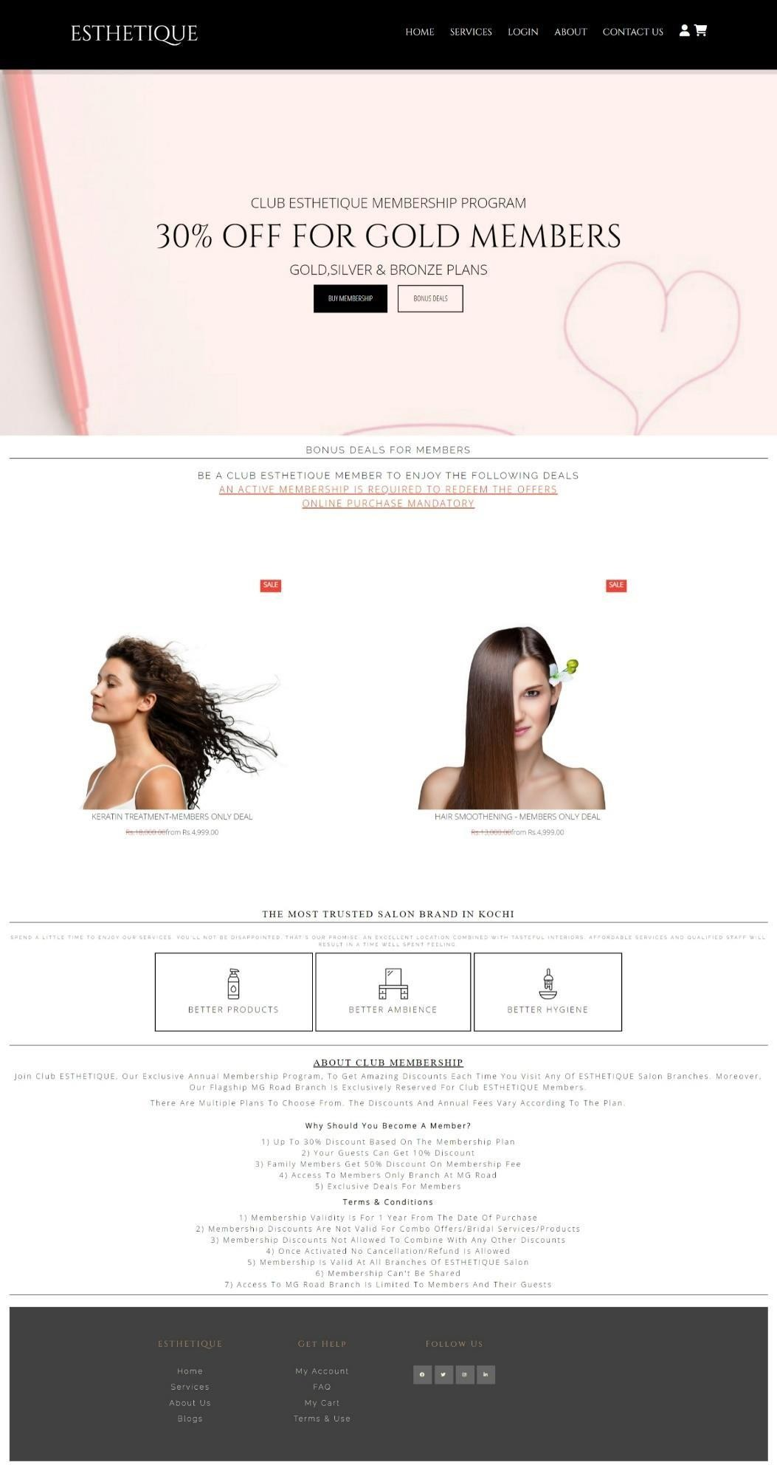

## SERVICES PAGE

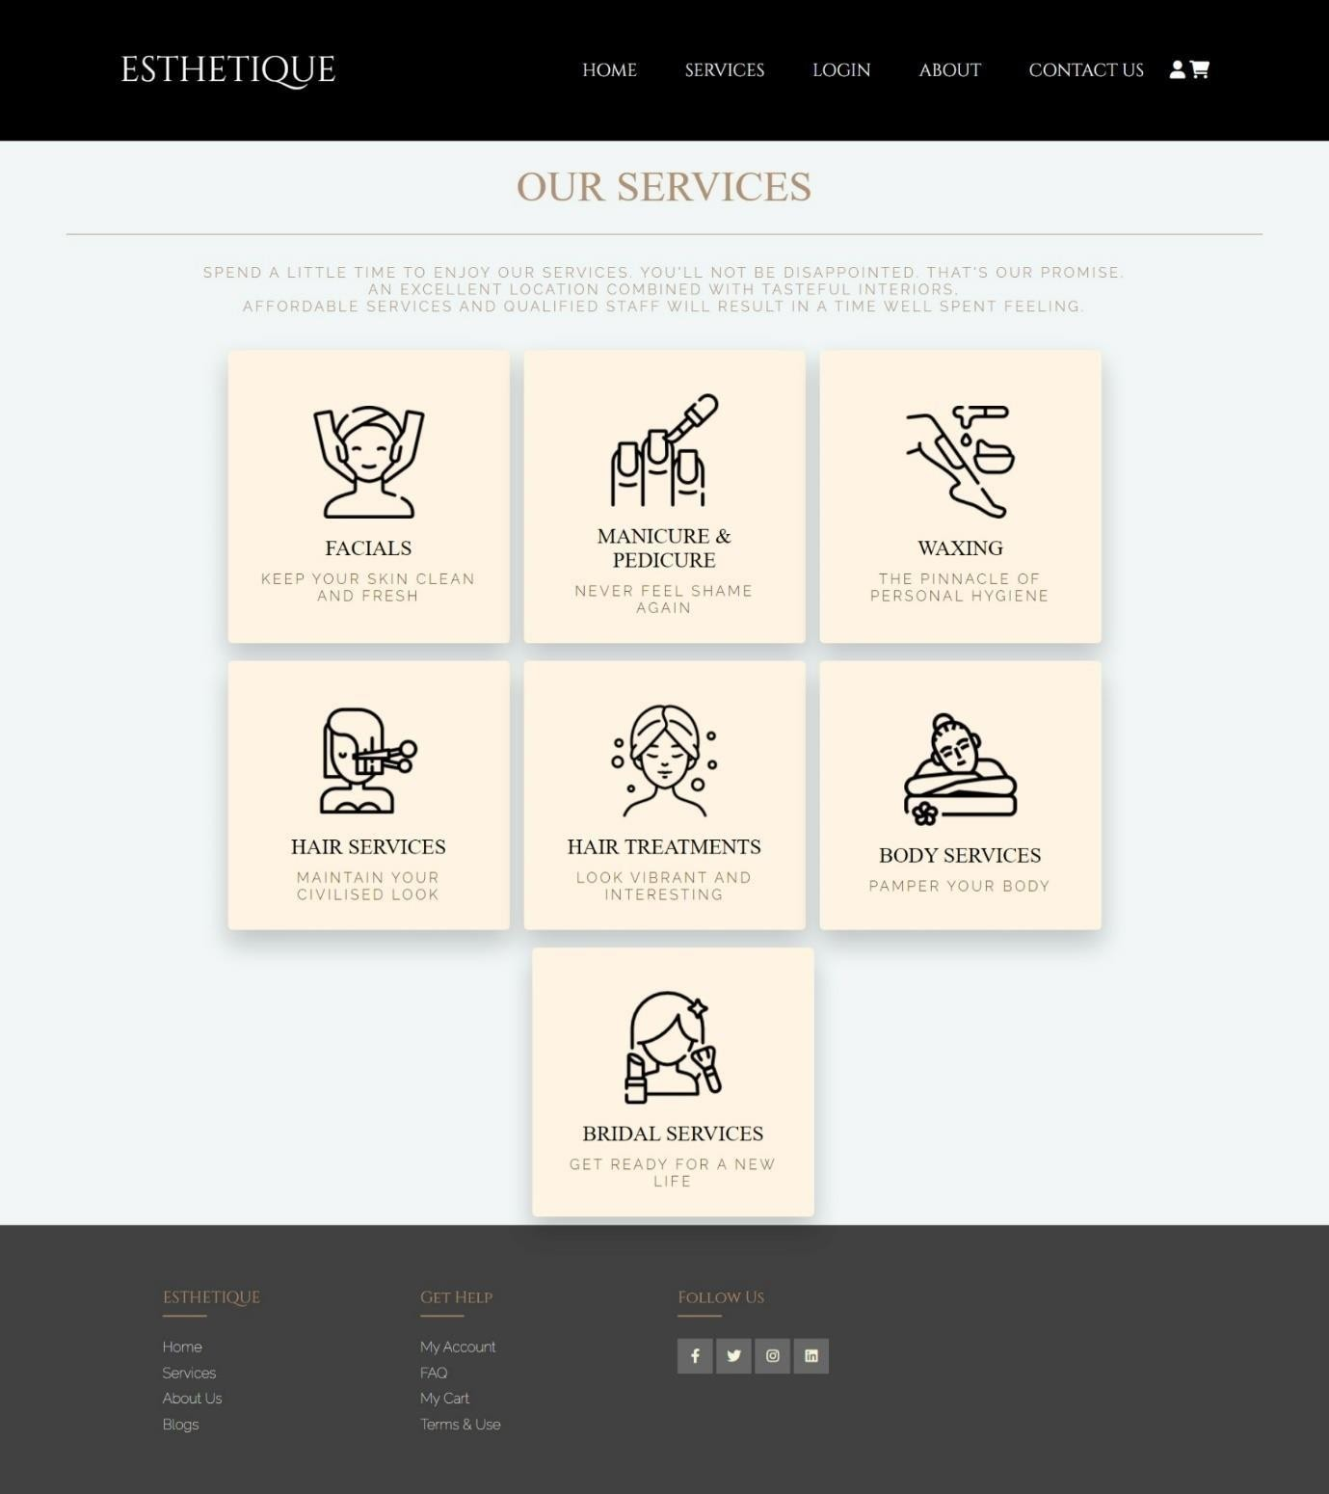

* + - 1. **LOGIN PAGE**

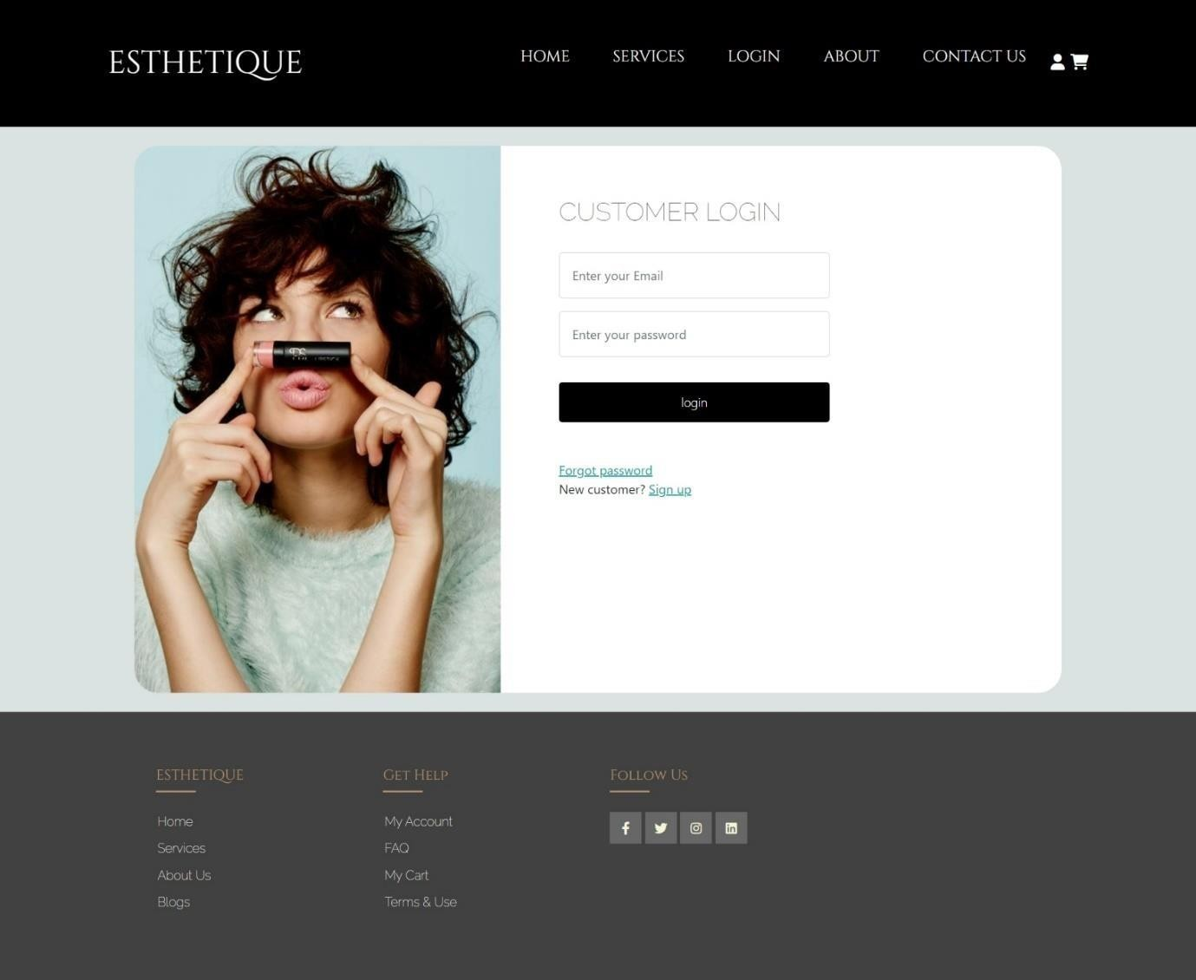

## ABOUT PAGE

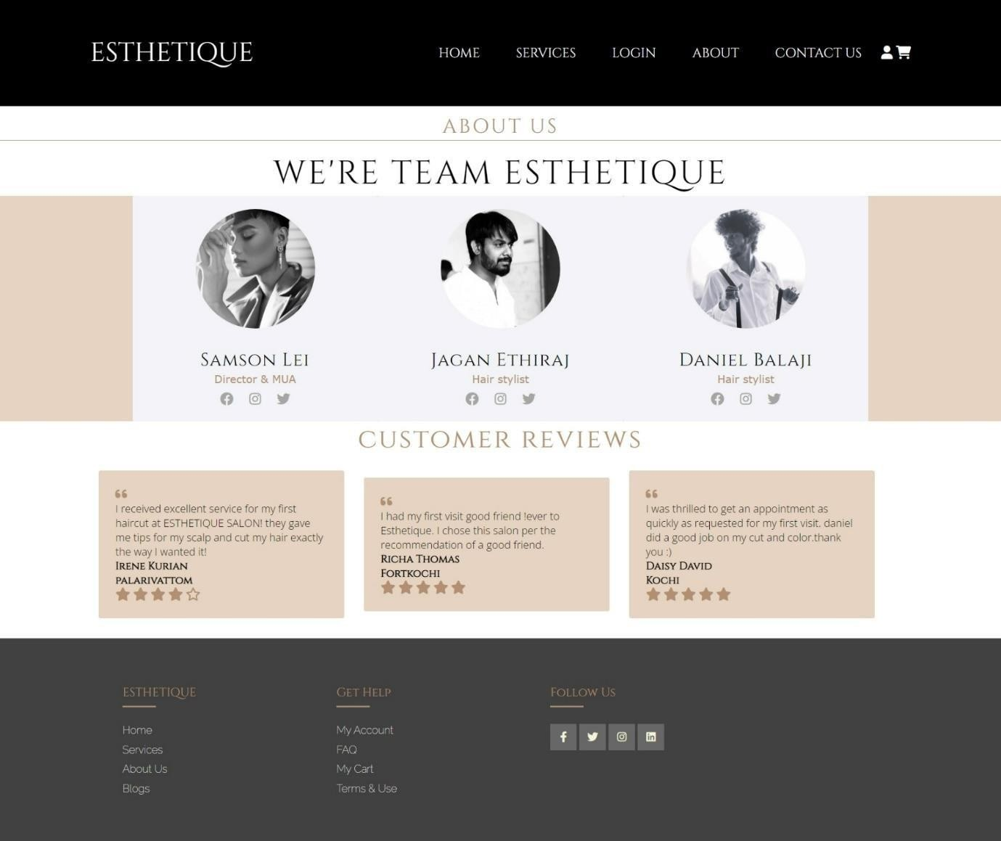

* + - 1. **CONTACT US PAGE**

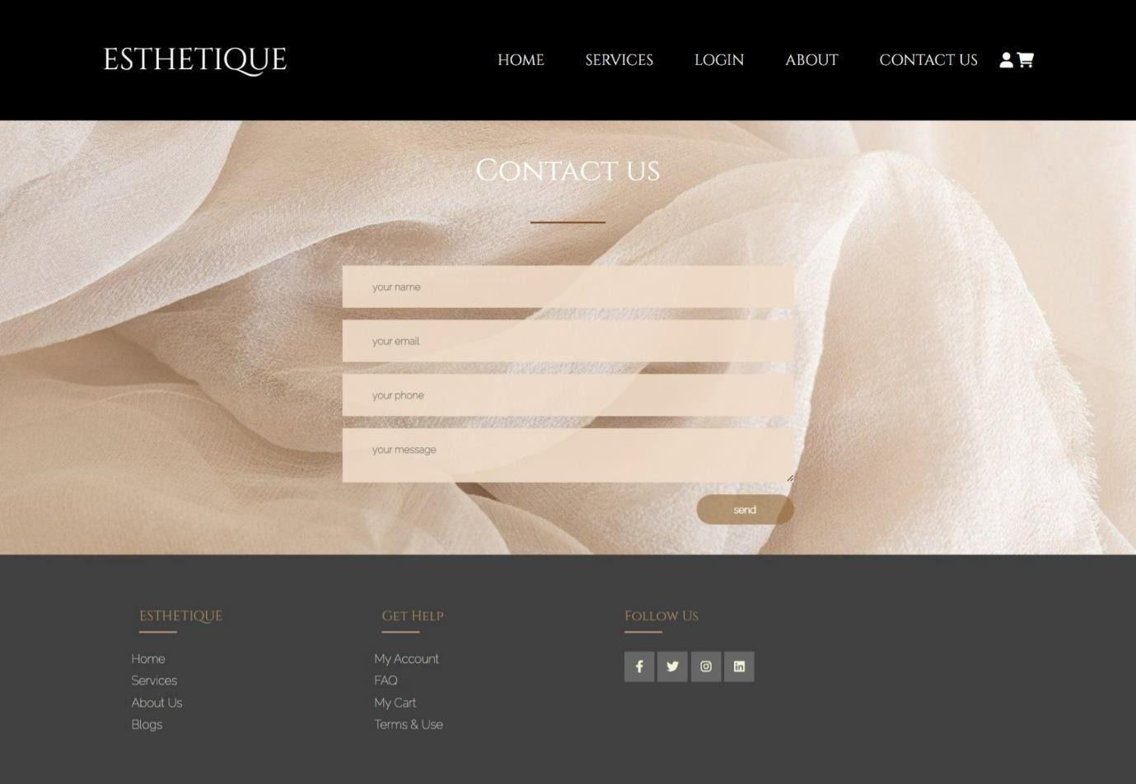

## BIBLIOGRAPHY

**WEBSITES:**

1. W3 SCHOOLS
2. YOUTUBE
3. BOOTSTRAP
4. FONT AWESOME